***Document Object Model***

*When a web page is loaded, the browser creates a Document Object Model of the page. The document object represents the whole html document as a tree of Objects(HTML, HEAD, BODY, and other HTML tags). It is the root element that represents the html document.*

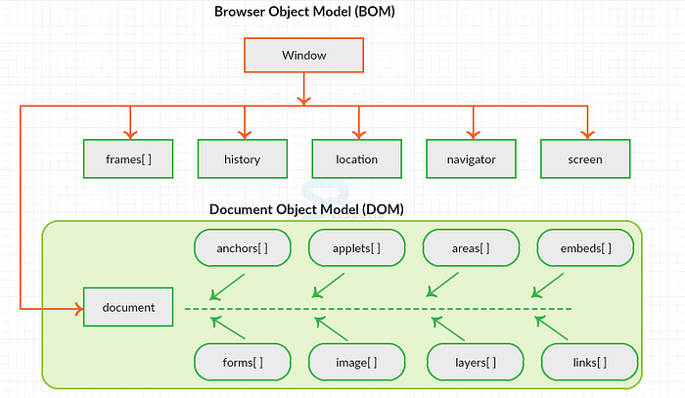

***Difference Between Document and Window Objects***

***Window object****: It is the top most object and outermost element of the object hierarchy*

***Document object****: Each HTML document that gets loaded into a window becomes a document object. The document contains the contents of the page. Using document object, JavaScript can modify, add and delete the HTML elements, attributes CSS styles in the page*

*The window object represents a window/tab containing a DOM document where as document object is property of window object that points to the DOM document loaded in that window.*

*You can access a document object either using window.document property or using document object directly as window is global object.*

***The other major difference is that both window object and document object have properties and methods.***

*When JavaScript is executed inside the browser, the window object is the JavaScript Global object. The document object is a property of the window object.*

*The window object represents the browser window.  
The document object represents the HTML document loaded in that window.*

*The window object has many useful properties like the location object and the setTimeout function.*

*Since the window object is the Global object, ergo, it is the end of all scope chains, you don’t have to explicitly specify it when accessing its properties…  
Instead of window.setTimeout, you can just write setTimeout  
Same goes with document… instead of window.document, you can just write document…*